SDLC Project – Sideways Elevator Panel

Christopher Gonzalez 11/28/2024

Customer: Hilton

This elevator will be able to go both vertical and horizontal. When you want to go up a floor, you can simply select the vertical option, choose your floor, and it will take you there. Similarly, wanting to go to another part of the floor you already are in works similarly. You select the horizontal option, choose a door that is available on your floor, and then you are transported where you need to. Works just like the elevators you are used to, but now can transport you across your floor.

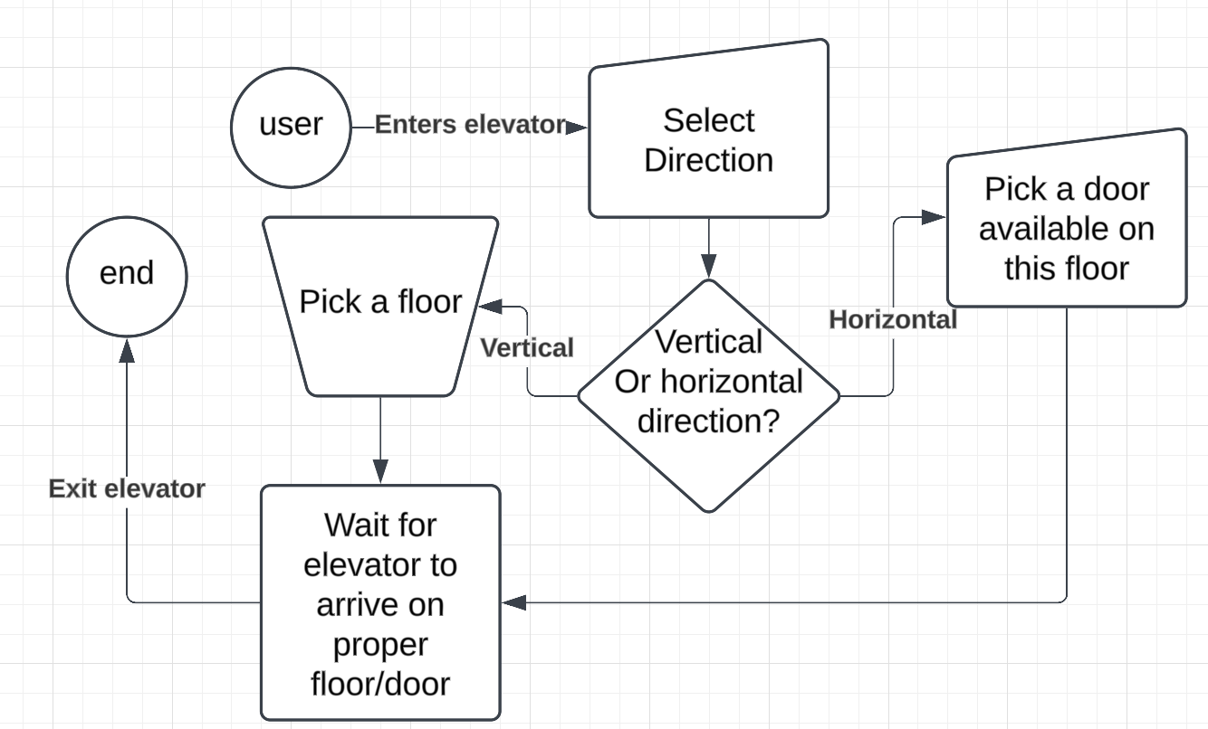 Select direction 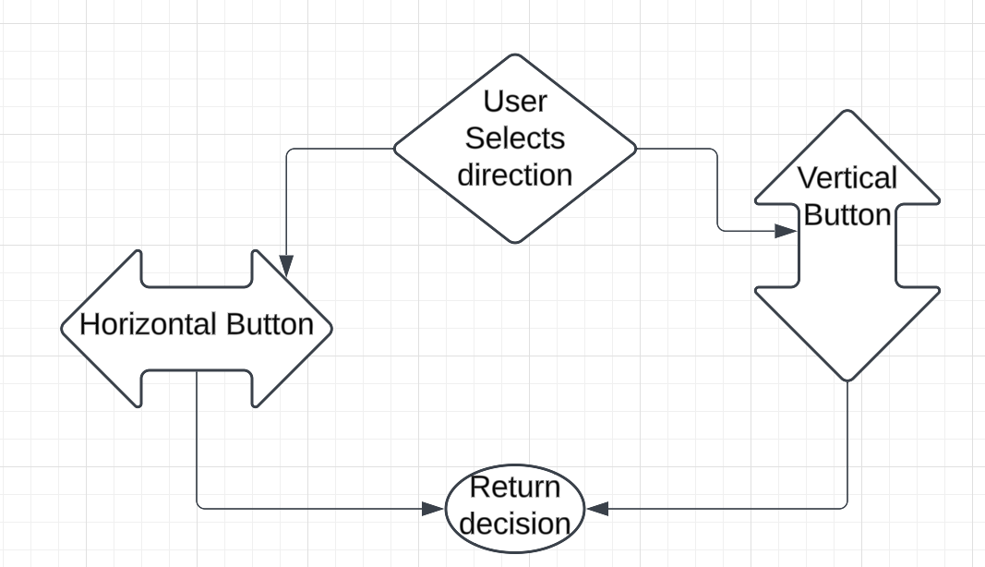

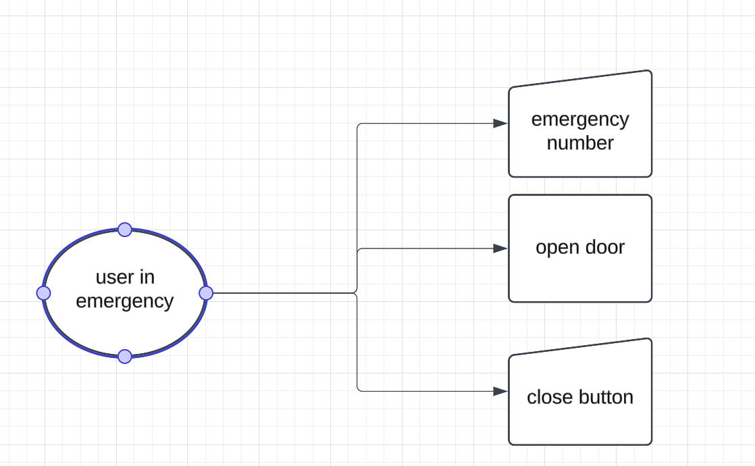

|  |  |
| --- | --- |
| Selection | Description |
| Test Plan ID | 1234 |
| Test Plan Name | Elevator goes to floor |
| Version | 1.5 |
| date | 11/18/2024 |
| Author | Christopher Gonzalez |
| Objective | Make the Elevator go to the Vertical floor when the button is pressed |
| Scope | What will be tested:   * Up or down, depending which floor we are going * The floor number button   The following won’t be tested:   * Fire emergency button * Close button * Open button |
| Test Strategy | Manually   1. Enter the front of elevator > Press down arrow button > enter elevator>press vertical Arrow Button> press desire floor number 1 > check that the floor button 1 lights up> wait for elevator to go to floor 1> leave elevator 2. Enter the front of elevator > Press up arrow button 9> enter elevator> press vertical Arrow button> press desired floor number 9> check that the floor button 9 lights up> wait for elevator to go to floor 9 > leave elevator 3. Enter the front of elevator > Press down arrow button 9> enter elevator> press vertical Arrow button> press desired floor number 9> check that the floor button 9 lights up> wait for elevator to go to floor 9 > Don’t leave elevator > press floor number 7 > check that the floor number 7 lights up> wait for the elevator to go down to floor number 7 > then leave elevator. |
| Testing schedule | Today>7:48PM |
| Scope | What will be tested:   * Going across the floor horizontally   The following won’t be tested:   * Fire emergency button * Close button * Vertically * Open button |
| Test Strategy | Manually   1. Enter the front of elevator >    1. Press left arrow button >    2. enter elevator>    3. press horizontal Arrow Button>    4. check that every door button available on this floor but 5 is lit up >    5. press desired floor number 2 >    6. wait for elevator to go to elevator 2 >    7. leave elevator 2. Enter the front of elevator >    1. Press right arrow button >    2. enter elevator>    3. press horizontal Arrow Button>    4. check that every door button available on this floor but 1 is lit up >    5. press desired door number 2 >    6. wait for elevator to go to door 2 >    7. leave elevator |
| Testing schedule | Tomorrow>7:48PM |